Use Cases Description
UC3- Statistic and Report

For

Meeting Room
Booking System
(MRBS)

Prepared by K15T1-Team11
Van Lang University
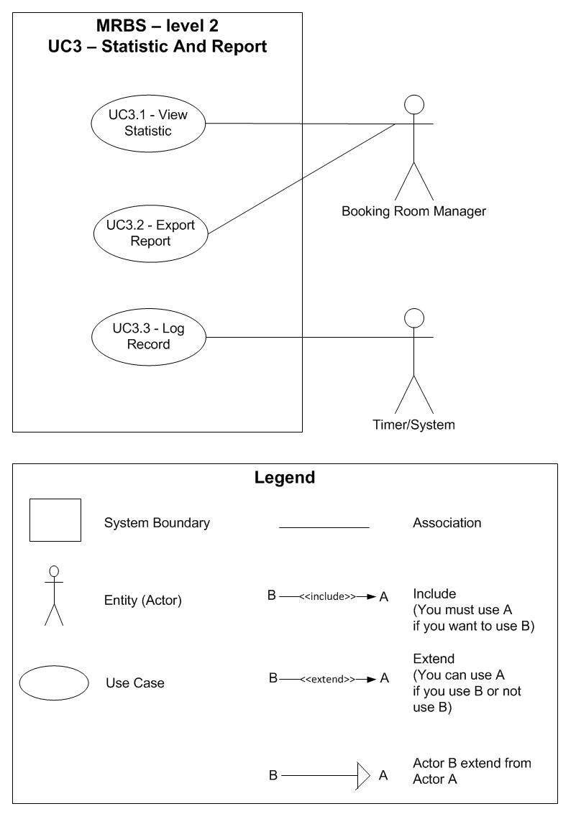
Table of Contents
UC3.1 – View Statistic 4
UC3.2 – Export Report 4
UC3.3 – Log Record 5

UC3.1 – View Statistic
ID | UC3.1
Name | View Statistic
Author | Son Dang | Modify by | Tam Do
Date | 06/18/12 | Update | 06/29/12
Actor | Booking Room Manager
Description | User can view statistic report by date, room or borrower
Precondition | User signed in system by Booking Room Manager’s account
Post condition: | System show report for whatever user choose
Main flow: | 1. User press “Thống kê báo cáo” tab  2. User choose type of statistic “Thống kê theo”  3. User choose “Thống kê”  4. System show report follow what user choose
Alternative flow:
Exception :
Includes:
Priority: | Very High
Business rules:
Mockup screen

UC3.2 – Export Report
ID | UC3.2
Name | Export Report
Author | Son Dang | Modify by | Tam Do
Date | 06/18/12 | Update | 07/06/12
Actor | Booking Room Manager
Description | User can export report with excel file (*.xls; *.xlsx)
Precondition | User signed in system by Booking Room Manager’s account
Post condition: | System open Microsoft Excel with the report template for user
Main flow: | 1. User press “Thống kê báo cáo” tab  2. User press “Xuất file” button  3. System prepair the report template  4. System open Microsoft Excel  5. System add the report template into Microsoft Excel
Alternative flow:
Exception :
Includes:
Priority: | High
Business rules:
Mockup screen

UC3.3 – Log Record
ID | UC3.3
Name | Log Record
Author | Tam Do | Modify by
Date | 06/29/12 | Update
Actor | Timer/System
Description | Timer will record whatever Booking Room Manager do when they use Booking Room Manager
Precondition | User signed in system by Booking Room Manager’s account  Booking Room Manager use Booking Room Management function
Post condition: | Timer record the activity of Booking Room Manager into database
Main flow: | 1. Timer save the activity of Booking Room Manager into database
Alternative flow:
Exception :
Includes:
Priority: | High
Business rules:
Mockup screen

